**PROJECT EXECUTION STEPS**

This project is a machine learning model to describe intrusion detection system by using NSL-KDD data set by using XG-Boost and LSTM algorithms. This can be executed by following steps:

* Double click on the given project source file i.e., mini2.ipynb and you can open it through google colab or also with jupyter notebook.
* Download NSL-KDD dataset from [www.kaggle.com](http://www.kaggle.com)
* Upload dataset into google drive and ount the drive with your notebook either google colab or jupyter notebook
* While connecting your drive to google colab you can observe below procedure to mount the drive

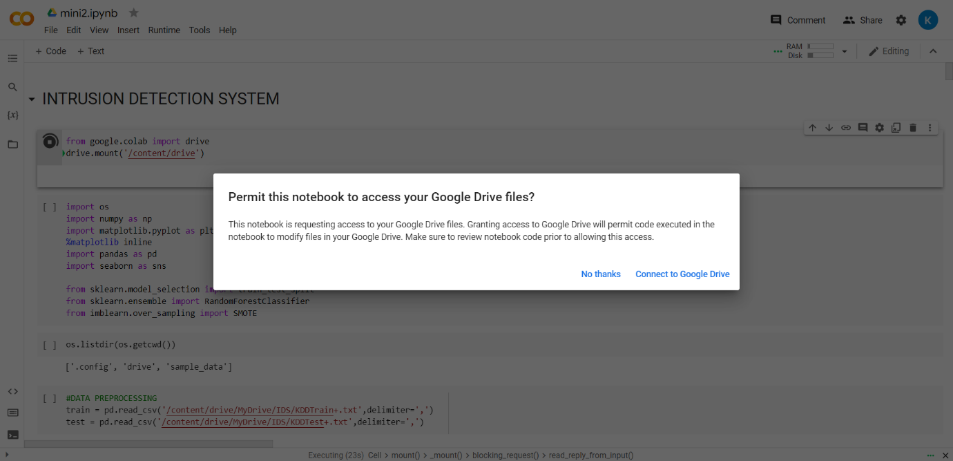

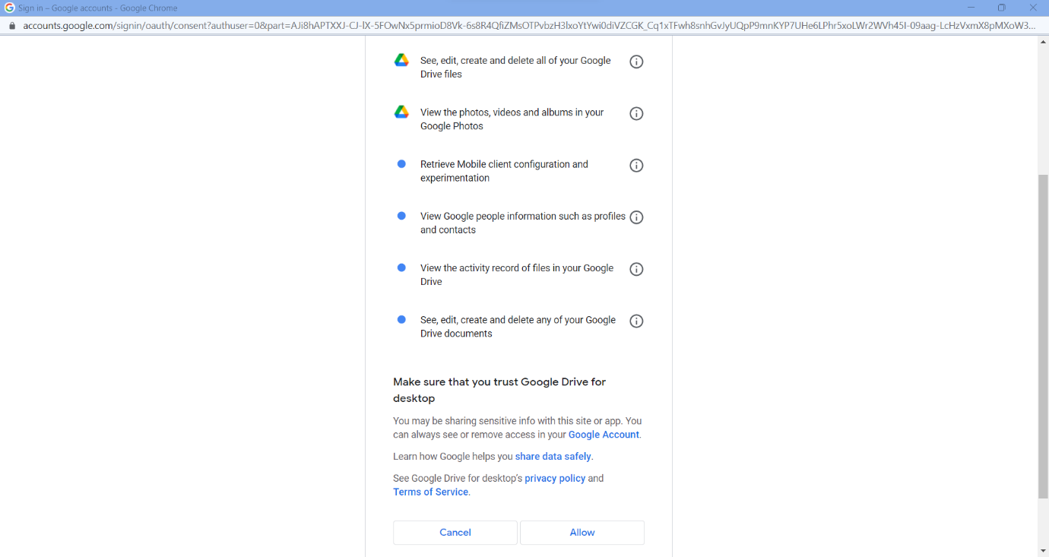

* Click on allow to complete the mount and the below screen is displayed and you can run each cell sequentially to observe intrusion detection by using NSL-KDD dataset.

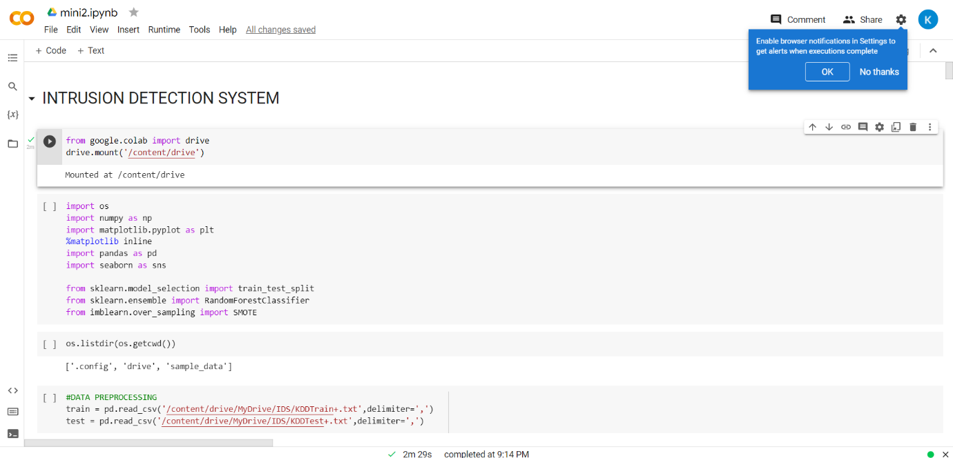

The project can be executed in this way by using above procedure.